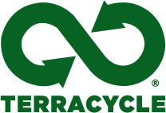

TerraCycle Holiday Gifts
TerraCycle is the world’s leader in upcycling and recycling previously non-recyclable post-consumer waste that would otherwise be destined for landfills. Each one of the affordable, innovative products below is repurposed from used packaging and products and will make exciting gifts this holiday season. All items are available for purchase at http://www.TerraCycleShop.com.
CONTACT: Emma Swanson at emma.swanson@terracycle.com

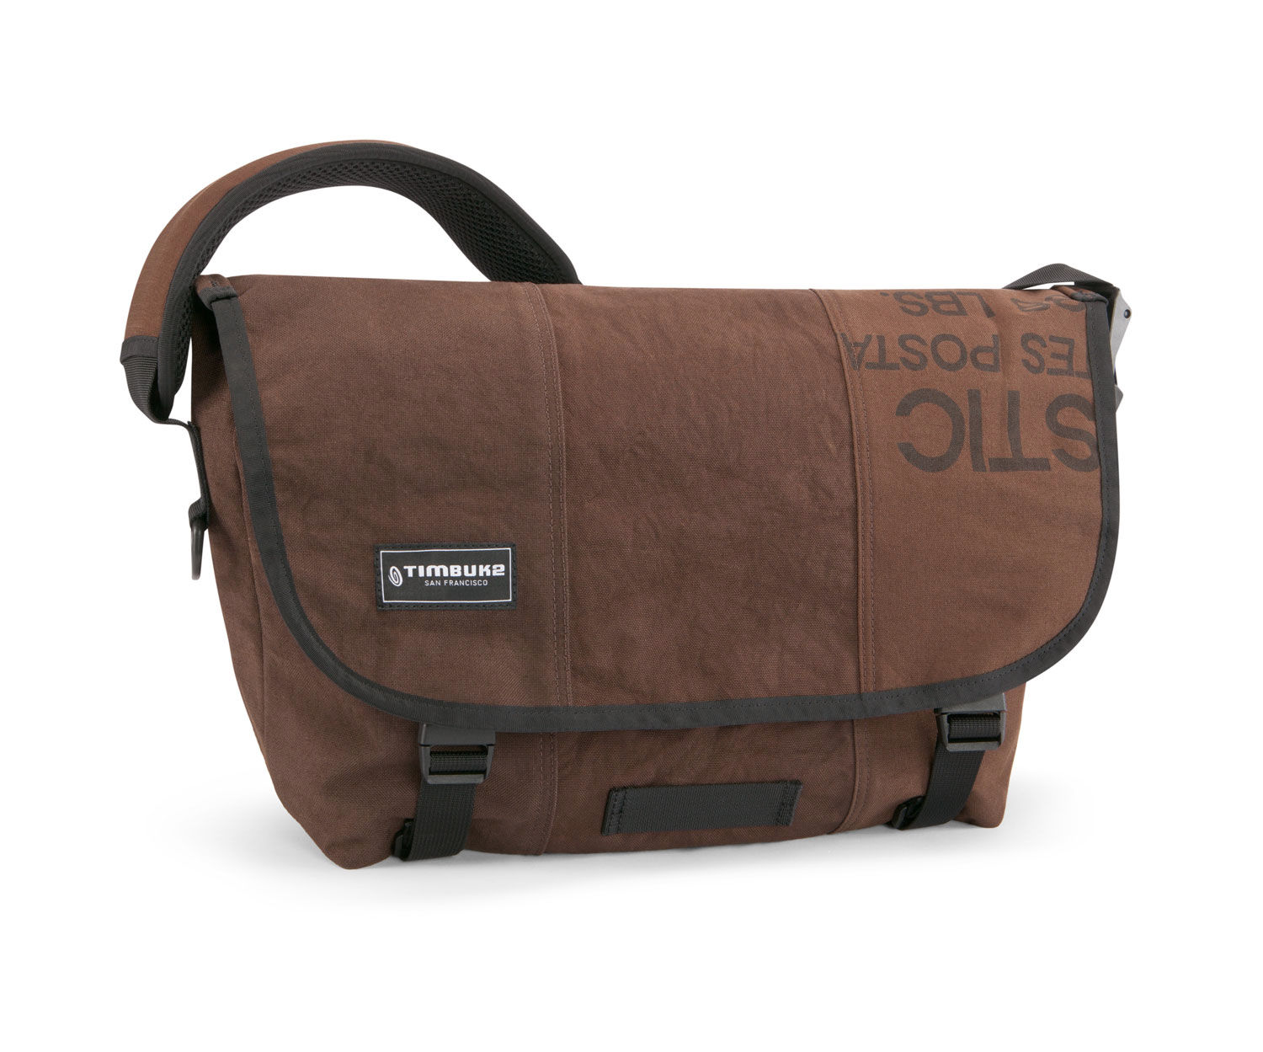
Messenger Bag
Material: Upcycled USPS mail bags
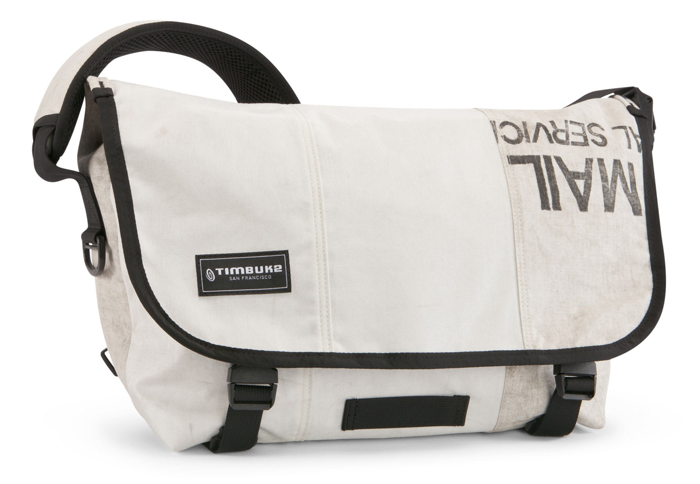
These waterproof bags are upcycled from retired United States Postal Service mailbags and are the perfect green solution for your everyday commute or business trip. All bags are designed with air mesh straps for complete comfort and pockets located inside make organizing your work or travel items easy. There are two different colored bags to choose from: brown or white. Each bag is handpicked and sewn together differently, giving every piece a unique design.
Price: $99.00

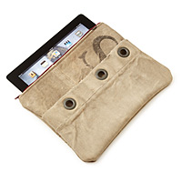

iPad/Tablet Case
Material: Upcycled USPS mail bags
What was once used to protect your mail can now be used to protect your email! TerraCycle’s iPad case is made from upcycled USPS mailbags, which are weatherproof and coated inside with gentle ultrasuede to protect your iPad or tablet from any surface damage. Each case is lined with a zipper to fully enclose your tablet and outside pockets can hold chargers and cords. Each mailbag has a unique history and rustic look that are reflected in your case.
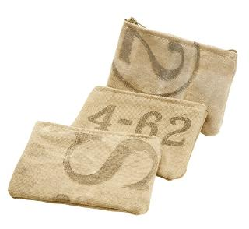
Price: $55.00

USPS Coin Pouch- $15.00
This coin pouch is crafted from a retired US Mail Bag. The one-of-a-kind pouch has a zipper close for organizing coins, makeup, and other small items.
Dimensions: 5.5" x 3.5"

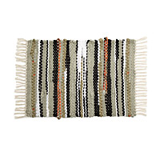
Rag Rug
Material: Upcycled tents
Tents that were once used as protection from the environment can now be used to protect it. Handmade from tents that would otherwise end up in a landfill, these rugs are stylish and eco-friendly. All material, from the nylon to the zipper, is beautifully woven into the rugs by designer Patricia Lukas. Each rug is a 3’L X 2’W, and a perfect fit for any room in the house.
Price: $130.00

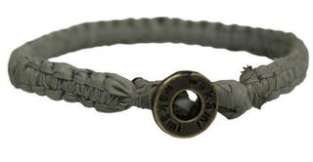
Bracelet
Both wilderness and beauty are captured in TerraCycle’s Tent Bracelet. This product is created in partnership with Wakami and produced responsibly in rural villages in Guatemala. All bracelets are made from tent material and have a design unique to the artisans who crafted them. Bracelets are approximately 7.25” in circumference.
Price: $12.00

